Rockhampton Bicycle Use Analysis

COIT12209
Data Science

Period Covered: 20/04/2026 – AA/BB/2026

MONTH 2026

Word Count:

Lachlan J. W. Wyer (12290303)

COIT12209 Lecturer and Tutor:
Mr. Arjun Neupane
Central Queensland University

Introduction:
In a time in which cost-of-living, car and fuel prices are forcing people to explore alternative transportation options. There are three main alternatives that can be utilized within regional and rural areas; public transport (i.e. buses and trains), car-pooling and bicycle riding. The main focus around this report will be bicycle riding. Without the data to find what drives consumer demand, there is no way for councils to prepare for such demand. One such rural council wanting to know this information is the Rockhampton council. As such, they have come forward with some questions to determine the overall outcome:
- Factors driving demand
- Usage through the year
- Whether future demand is possible to be predicted
By knowing the answer to these questions, Rockhampton council hopes to know when to temporarily increase the number of bikes to meet expected demand.

Assumptions

Initial Data Exploration:
As shown in Table 1, as basic 4-number summary and standard deviation was used. This style of summary illustrates clearly wrong data points (e.g. Rockhampton does not get temperatures very below zero) as well as some outlier data points. The clearly wrong data points include temperatures very below 0ºC and max of 100 ºC, humidity below zero and 500%, as well as the Min and Max of count.
The standard deviation also gives an indication on variations around a data points mean. As such most of the different columns within the dataset are considered tight. This is because most of the data’s standard deviation is quite small. However, the count column, counting the number of bicycles used, has a standard deviation of 2016.87. This is very large swings in the data presented around the mean of 77.75.
Table 1 - Basic number summary
 | Min | Max | Mean | Median | Standard Deviation
Holiday | 0.0 | 1.00 | 0.07 | 0.0 | 0.26
Working Day | 0.0 | 1.00 | 0.66 | 1.0 | 0.47
Temp | -25.0 | 100.00 | 22.08 | 21.9 | 6.85
Atemp | 6.0 | 37.72 | 22.42 | 22.5 | 5.25
Humidity | -20.0 | 500.00 | 59.11 | 58.1 | 24.20
Windspeed | 0.8 | 20.30 | 10.43 | 10.3 | 3.26
Count | -100.0 | 50,000.00 | 77.75 | 686.0 | 2016.87
Source – Author
To illustrate these variations presented a box plot is used. The dots illustrate the number of datapoints within the dataset. As shown in Figure 1, the count as 4 outlier points, drastically increasing until the max point is found. Figure 2 however, is much more contained but still has a significant number of outliers that are both larger and smaller the IQR.

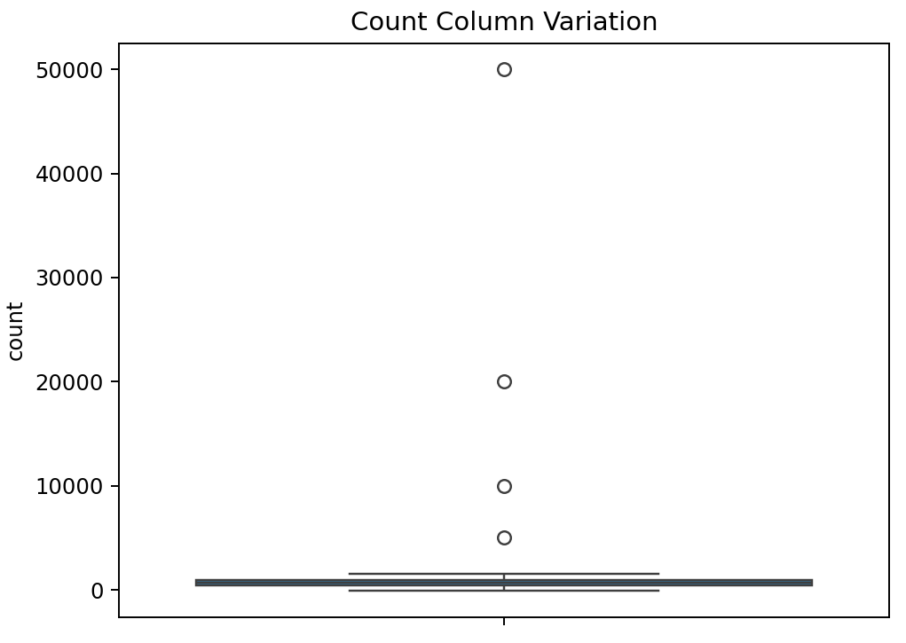
Figure 1 - Count column boxplot
Source - Author
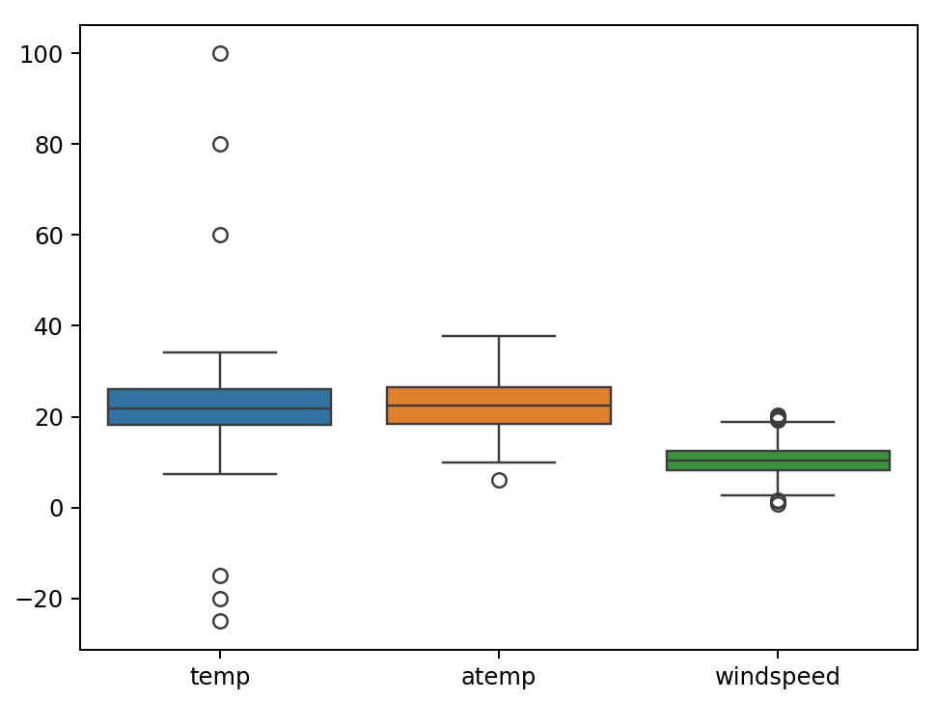
Figure 2 - Large standard deviation columns
Source – Author

It was also found that there was a number of rows of data that has points missing (~3.45% of the whole column). This will eventually skew the data around the mean and any information presented beforehand. Since the percentage of a column within the dataset as a NULL value is ~3.45%, the rows this is presented in will be replace with that mean from the column. Whilst it would affect the specific accuracy of the dataset, there are not enough NULL values (>5.5%) to require a full rewrite of the dataset (GeeksforGeeks 2026).

Data Cleaning:
All duplicated values are dropped.
Null values are replaced with the mean.
Fix outliers. Anything outside of 3 stds of the mean (encapsulates 99% of all considered normal points). All negative values will be change to 0. Will inevitably remove some actual crazy outliers. The only way is to actually compare values with another dataset. E.g. Temperature values with the comparison from the BOM dataset. This is done twice to achieve 98.01% of the complete dataset.

